07/09/2026
PYTHON:
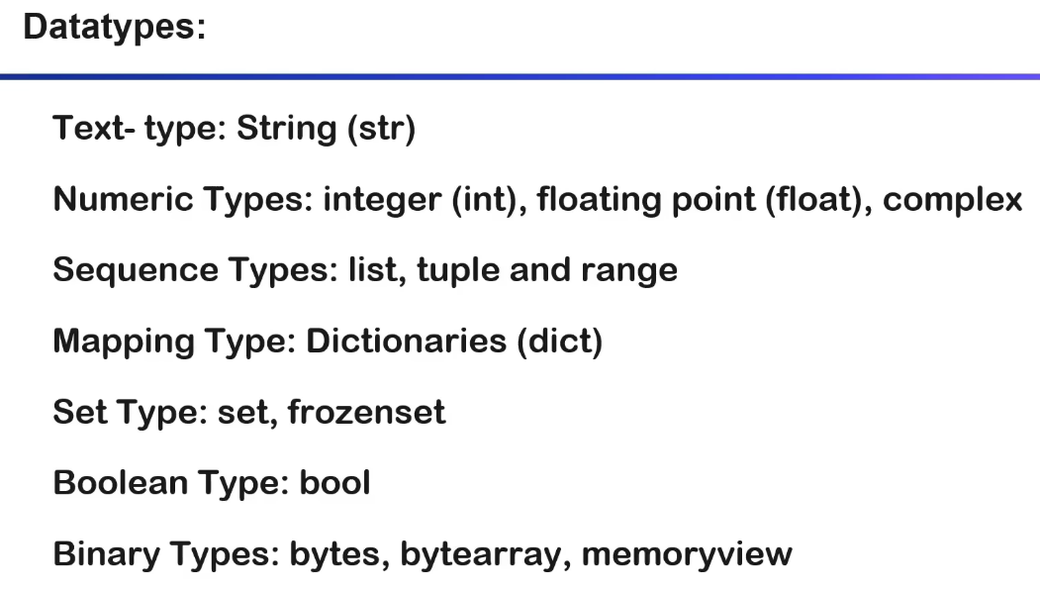

Eval Evaluates expressions like (2+3), print(“hello”), and so on.
Bin() Finds binary value of a number.

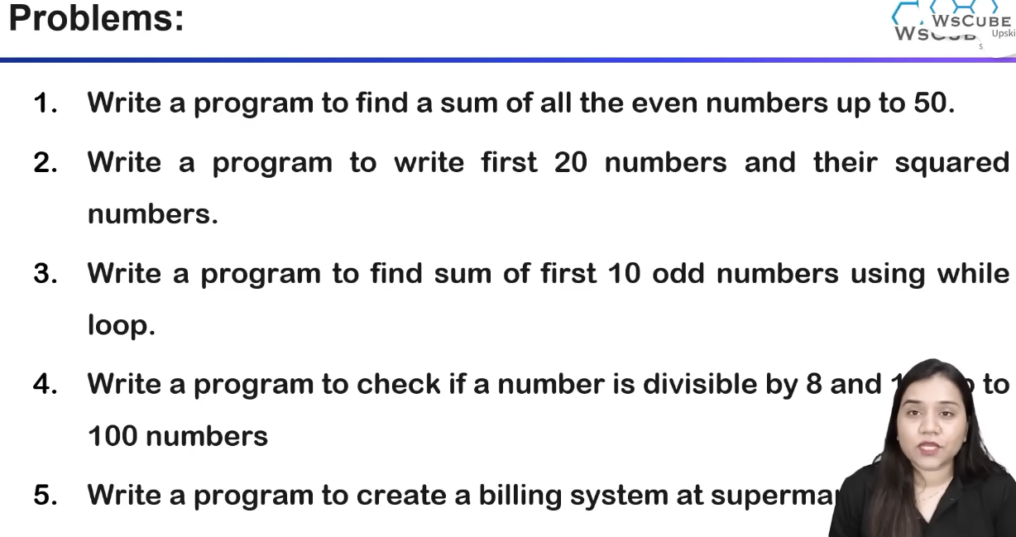
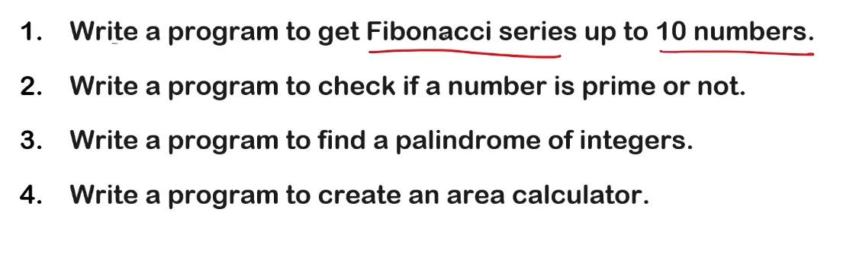
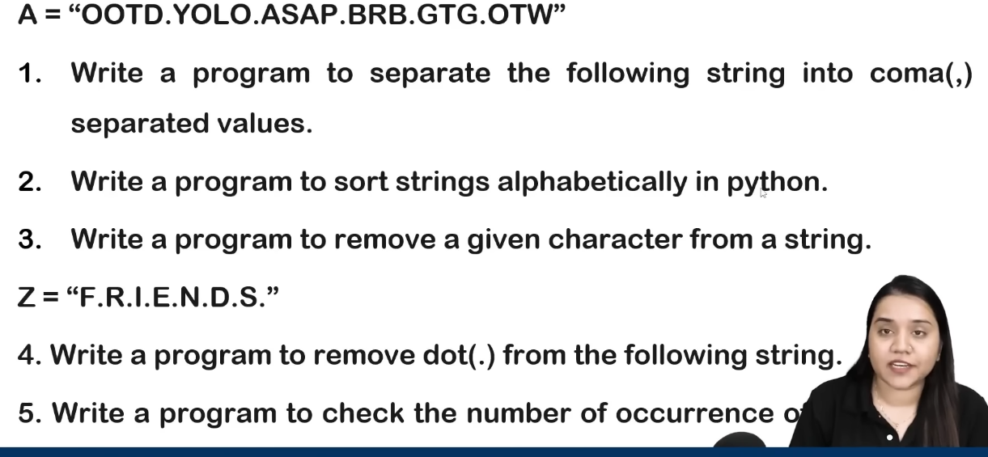

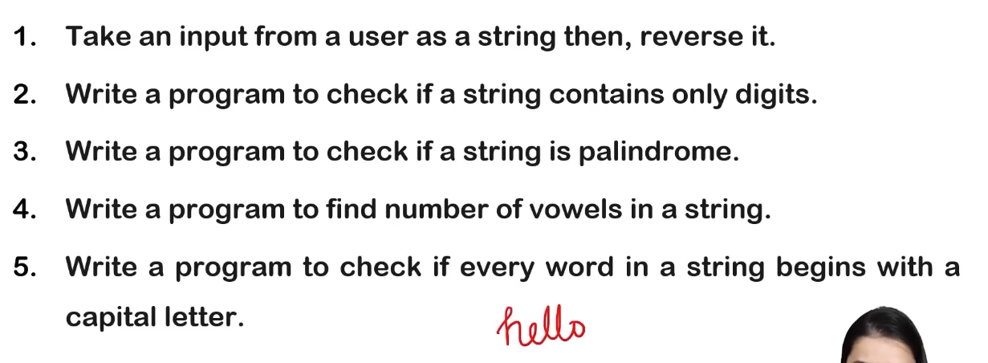
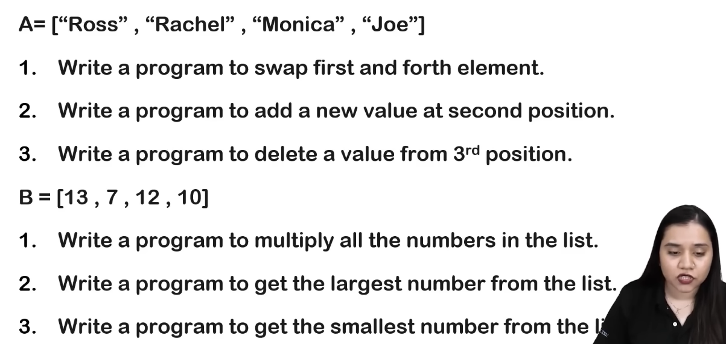
Dictionaries:
Functions:
- Get c.get(key)
- Items c.items()
- Keys c.keys()
- Values c.values()
- Copy c.copy()
- Setdefault
- Update
- Pop
- Popitem
- Clear

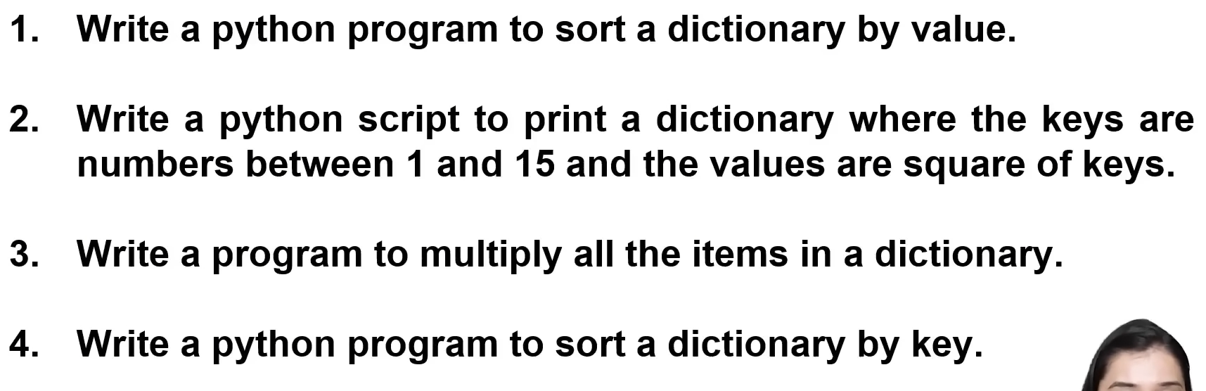

Case conversion
s.upper() # "HELLO WORLD"
s.lower() # "hello world"
s.capitalize() # "Hello world"
s.title() # "Hello World"
s.swapcase() # "HELLO WORLD" -> "hello world"
s.casefold() # aggressive lowercase
Searching
s.find("world") # index, or -1
s.rfind("o") # search from right
s.index("world") # index, raises ValueError if absent
s.rindex("o") # rightmost index
s.count("l") # 3
s.startswith("hello") # True
s.endswith("world") # True
Checking content
s.isalpha() # only letters
s.isdigit() # only digits
s.isdecimal()
s.isnumeric()
s.isalnum() # letters/numbers
s.islower()
s.isupper()
s.isspace()
s.istitle()
s.isascii()
s.isidentifier()
Removing/replacing
s.strip() # remove whitespace both sides
s.lstrip() # left
s.rstrip() # right
s.strip("!") # remove specified characters
s.removeprefix("hello")
s.removesuffix("world")
s.replace("world", "Python")
Splitting
s.split() # split on whitespace
s.split(" ")
s.rsplit(" ", 1)

s.splitlines()

s.partition(" ")
s.rpartition(" ")
Example:
"a,b,c".split(",")
# ['a', 'b', 'c']
Joining
",".join(["a", "b", "c"])
# "a,b,c"
Formatting
name = "John"
age = 25

f"{name} is {age}"
"{} is {}".format(name, age)
"{name} is {age}".format(name=name, age=age)
Encoding
s.encode()

LISTS
Adding elements
lst.append(40)
lst.insert(1, 15)
lst.extend([50, 60])
Difference:
lst.append([40, 50])
# [10, 20, 30, [40, 50]]

lst.extend([40, 50])
# [10, 20, 30, 40, 50]
Removing elements
lst.remove(20) # removes first matching value
lst.pop() # removes/returns last element
lst.pop(1) # removes/returns index 1
lst.clear() # removes everything
Searching
lst.index(30)
lst.count(30)
Ordering
lst.sort()
lst.sort(reverse=True)

lst.reverse()
sort() modifies the original list:
lst.sort()
sorted() creates a new list:
new_lst = sorted(lst)
Copying
lst.copy()
Also:
new_lst = lst[:]
Useful list operations
len(lst)
max(lst)
min(lst)
sum(lst)
sorted(lst)
reversed(lst)
List slicing:
lst[start:stop:step]

lst[1:4]
lst[::-1]
List comprehension
Not a method, but extremely important:
[x * 2 for x in lst]
With condition:
[x for x in lst if x > 10]

3. Tuples — tuple
Tuples are immutable and ordered.
t = (10, 20, 30)
Tuple has only two methods:
t.count(10)
t.index(20)

len(t)
max(t)
min(t)
sum(t)
sorted(t)
Indexing:
t[0]
t[-1]
Slicing:
t[1:3]
t[::-1]
Concatenation:
(1, 2) + (3, 4)
:
(1, 2) * 3
# (1, 2, Repetition 1, 2, 1, 2)
Unpacking:
a, b, c = (10, 20, 30)
Extended unpacking:
a, *middle, b = (1, 2, 3, 4, 5)

4. Sets — set
Adding
s.add(4)
s.update([5, 6, 7])
Removing
s.remove(3) # raises KeyError if absent
s.discard(3) # doesn't raise error
s.pop() # removes arbitrary element
s.clear()
Set operations
Suppose:
a = {1, 2, 3}
b = {3, 4, 5}
Union:
a.union(b)
a | b
# {1, 2, 3, 4, 5}

Intersection:
a.intersection(b)
a & b
# {3}
Difference:
a.difference(b)
a - b
# {1, 2}
Symmetric difference:
a.symmetric_difference(b)
a ^ b
# {1, 2, 4, 5}
Relationship checks
a.issubset(b)
a.issuperset(b)
a.isdisjoint(b)
Operators:
a <= b # subset
a < b # proper subset
a >= b # superset
a > b # proper superset
Updating sets
These modify the original set:
a.update(b)
a.intersection_update(b)
a.difference_update(b)
a.symmetric_difference_update(b)
Copy
a.copy()

5. Dictionaries — dict
Dictionaries store key-value pairs.
d = {
"name": "John",
"age": 25
}
Accessing values
d["name"]
d.get("name")
d.get("salary", 0)
Important:
d["salary"]
raises KeyError if the key doesn't exist.
Whereas:
d.get("salary")
returns None.
Adding/updating
d["age"] = 26

d.update({
"city": "Hyderabad",
"age": 27
})
Removing
d.pop("age")
d.pop("age", None)

d.popitem() # removes last inserted key-value pair
d.clear()
Keys, values, items
d.keys()
d.values()
d.items()
Example:
for key, value in d.items():
print(key, value)
Checking keys
"name" in d
"name" not in d
Note that:
"name" in d
checks keys, not values.
Copying
d.copy()
Again, this is a shallow copy.
setdefault()
Very useful:
d.setdefault("age", 25)
If "age" exists, its existing value is kept. Otherwise, "age": 25 is inserted.
Example:
d = {}

d.setdefault("skills", []).append("Python")
d.setdefault("skills", []).append("SQL")

print(d)
# {'skills': ['Python', 'SQL']}

